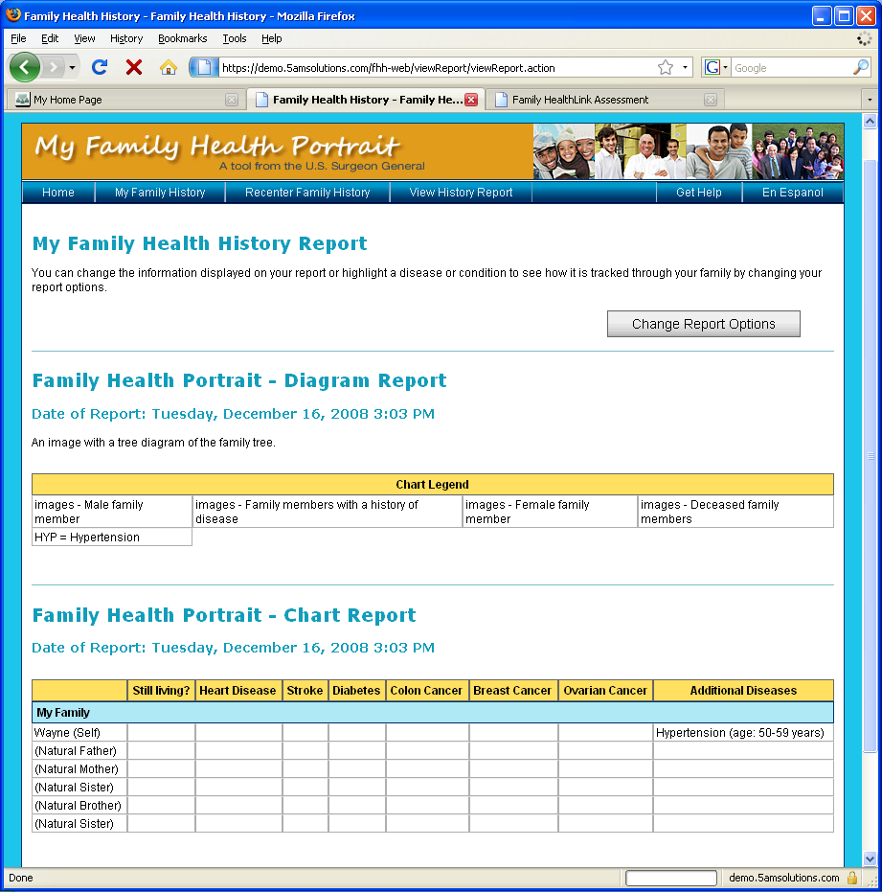

View History Report Help
On this page, you can:
- View your family history as a drawing or a table.
- Click on ‘Printer Friendly’ to see a version of this page that can be saved or printed.
- Click on Change Report Options to customize this report.

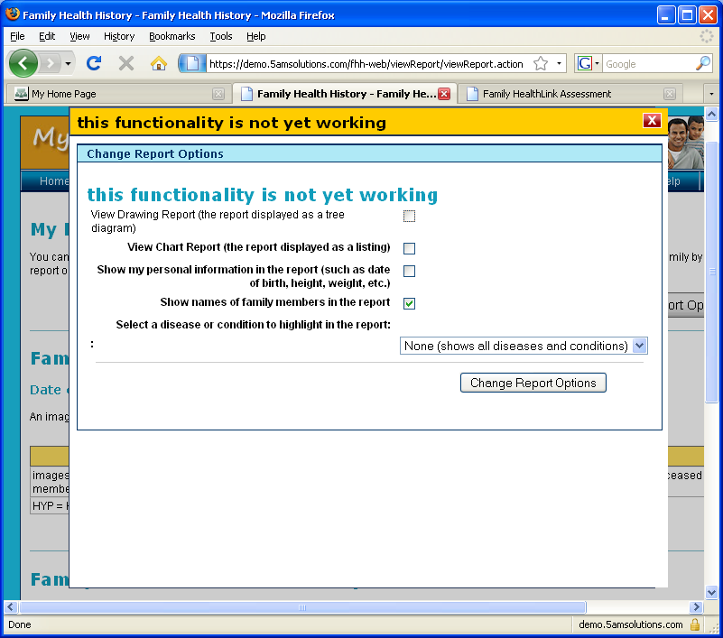

Customize Chart Help
You can customize the picture and table in a few ways.
- Choose a disease or condition in the drop down list to highlight in the picture and table.
- Check the box to show your age, height, and weight.
- Check the box to show the names of your family members in the report.
- Check the box to view the picture.
- Check the box to view the table.

Click change report options to see the customized version.

